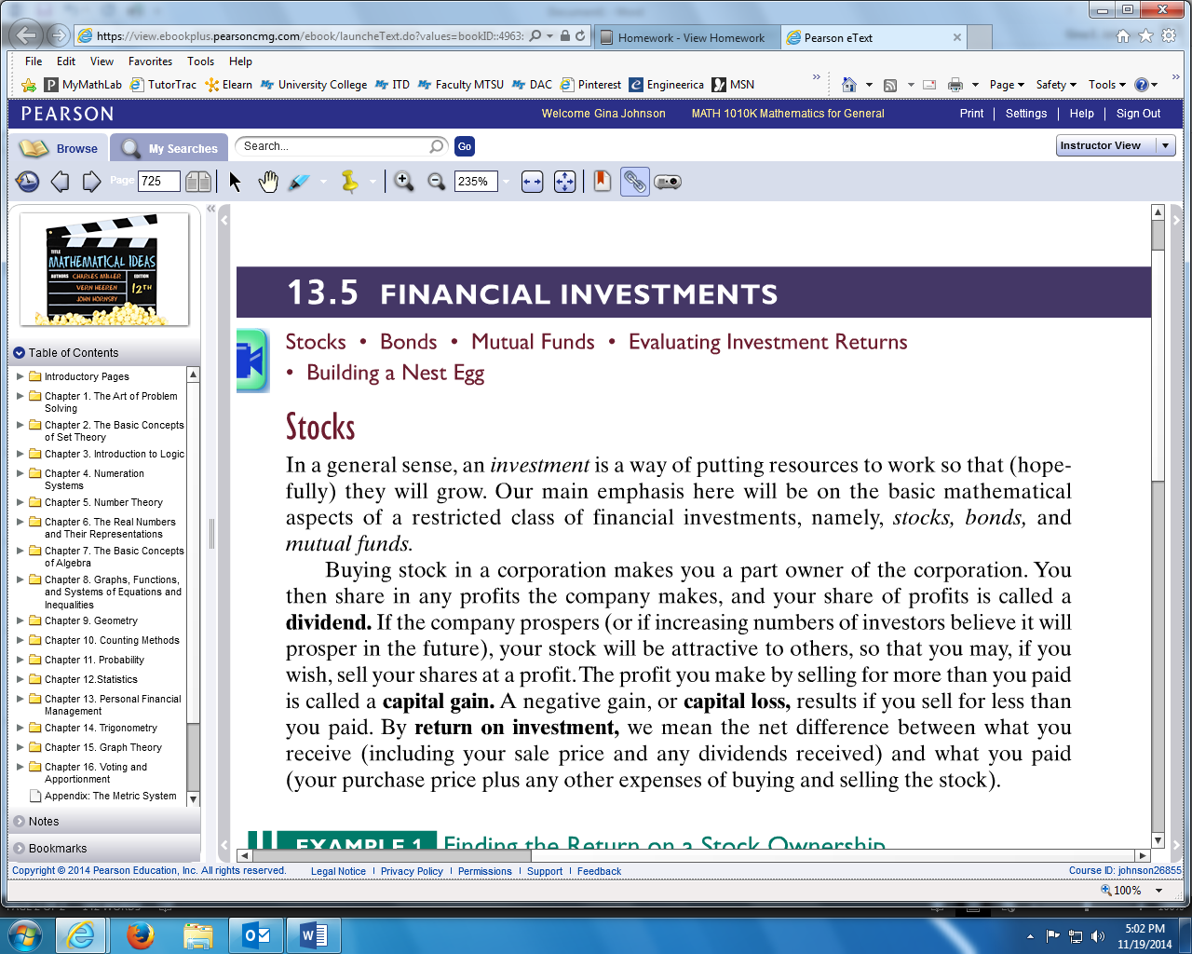

**EXAMPLE:** Lauren bought 100 shares of stock in a company on January 15, 2010 paying $30 per share. On January 15, 2011, she received a dividend of $0.50 per share and the stock price had risen to $30.85 per share. Find the following:

1. What was Lauren’s **total cost** for the stock?
2. What was the total **dividend**?
3. What was Lauren’s **capital gain** if she sold her stock in 2011?
4. What was Lauren’s **total return** on her one year investment?
5. What was Lauren’s **percentage return** on her investment?